

**Course:** Network Concepts

**Professor:** Dr.Sette

**Project Name:** Small Office Network Expansion

**Project Members:** RojaDhanavath,

**Table of Contents**

Introduction ……………………………………………………………………………………….2

About Us…………………………………………………………………………………………..3

Project Requirements……………………………………………………………………………...3

Existing Conditions………………………………………………………………………………..4

Changes to the System…………………………………………………………………………….5

Advantages of Components……………………………………………………………………….6

Project Limitations………………………………………………………………………………...6

What We Used…………………………………………………………………………………….7

Conclusion………………………………………………………………………………………...7

Introduction

We have been hired by a small business to expand their small network to suit their growing clientele. The business is a pet care service that boards pets while their owners are away from home, as well as shelters stray pets. They have recently added onto their office building, and decided that this would be the right time to change their network. What they originally had was two desktop PCs connected to a server. What we have expanded it to is another desktop on the main connection, as well as added another section to the network for wireless devices such as laptops, smartphones, and tablets, as per their request. With this, employees will be able to access important data without being tied to the PCs in the front desk and main office. We have also added a printer to the network so that the employees can print off important data for filing.

About Us

Our company name is PDC Technologies. We are a small company and we specialize in small offices and home offices. We established ourselves in ourselves in 2016, and while we currently have a small taskforce, we have taken on a constant stream of work in order to develop ourselves professionally.

Project Requirements

The main requirement for this job is ensuring that the wireless connection provides proper service throughout the entire office. The client’s current equipment is modern and compatible with our network, and they have recently purchased the new computers that they wish to add on. The mobile devices are the employees’ personal devices, so they are not needed to be provided by the client. The client was previously using a minimal amount of power, essentially just what was previously being used for the network as well as basic functions such as the lights. A switch, a router, a wireless access point, and a means of charging the laptops will not require more power than what the client has access to. A wire will be needed to connect the new switch to the current one, as well as another wire to connect the wireless access point to the new switch. We have chosen to use Cat6 wire for this project, due to being more “future proof” than Cat5E wire, and is more appropriate for commercial purposes than Cat6A. A device rack is needed for storing the laptops when they are not in use, as well as company off hours.

Existing Conditions

What the client had when they hired us was two PC’s, one at the main desk and one in the boss’ office. The PC at the main desk is used for entering and storing customers’ data, while the boss’ PC is used for viewing resources and budget management, though the boss can view customer data as well.

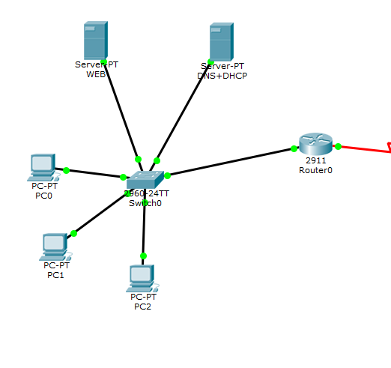

Changes to the system

We will not need to change the way the client’s current system works. Instead, we are adding onto their network to add more functionality. The client requested a way to connect portable devices such as laptops and smartphones to their system, so what we are providing is wireless accessibility to their existing network with a new switch and a wireless access point.

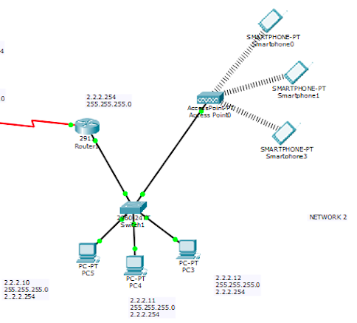

Advantages of using the components

With the previous system, the employee at the main desk would have to handle all data entry, and would be the only one besides the boss capable of viewing customer data. Now, employees can look up needed data on the pets they are tending to from anywhere in the office, and even outside if they are tending to pets in the open activity areas. Similarly, on the old system, the boss was confined to the main office in order to manage the budget and inventory. Now, the boss can access the needed data on the laptops throughout the office, if authorized, and can choose to send inventory data to employees if requested. With the addition of the printer to the network, important data for each pet can be printed off and stored in a file slot next to each individual kennel. This allows employees to have easy access to any needed information about a pet before they are taken out of their kennels for personalized care.

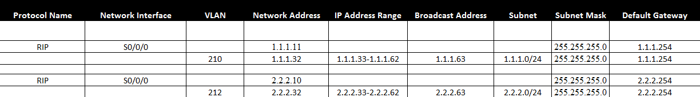

Project Limitations

There were not many limitations with this project. Due to the growing clientele, the company was able to afford the needed equipment, so there were no budgetary concerns on our end. In terms of installation, the client requested that the wireless access point be installed towards the back of the office, since that is where the pets are boarded, and thus, where the employees do the bulk of their work. The primary switch is located at the front of the office, so this required a wire being run through the wall. The issue here was that the client did not want to create any new holes in the wall, so the wire had to be run into the same hole as the original switch, and had to be run out of a previously unused port in the back of the office. The access point remained by the wall, as requested by the client, and while not in the most optimal location, it still provides adequate service to the entire office.

What We Used

* Packet Tracer 7.0
* Web and DNS+DHCP Servers
* RIP Protocols
* Cat6 Wiring
* Serial Router Connection

**Web Server-** A Web server is a program that uses HTTP (Hypertext Transfer Protocol) to serve the files that form Web pages to users, in response to their requests, which are forwarded by their computers' HTTP clients. Communication between a web server and web client is an example of an interaction between several protocols.

**DHCP Server-** DHCP stands for Dynamic Host Configuration Protocol. This is a network protocol in which computers request various IP addresses from DHCP servers, and the servers are able to assign unique addresses to dynamic computers. The use of DHCP means that computer operators no longer need to manually assign the computer an IP address or put in all of the information by hand.

**DNS Server-** DNS stands for Domain Name System. Every website on the Internet has a unique IP address. IP addresses are very difficult to remember, as they are just long strings of numbers. Instead of using IP addresses, websites use memorable names such as Google or eBay. The issue is that computers are not able to identify words as easily as they can identify numbers. DNS is a system that is able to translate website names into their specific IP addresses. When a website's name is typed as a URL, the computer uses DNS to translate the name into the IP address so that the computer knows which site to go to.

**RESULTS-**

When trying to access the website from the DNS server.

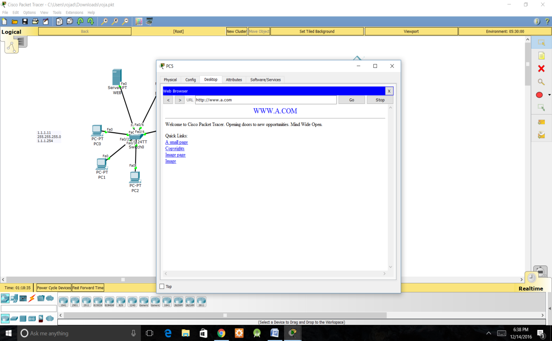

When trying to connect the PC5 from Network 2 to Network 1

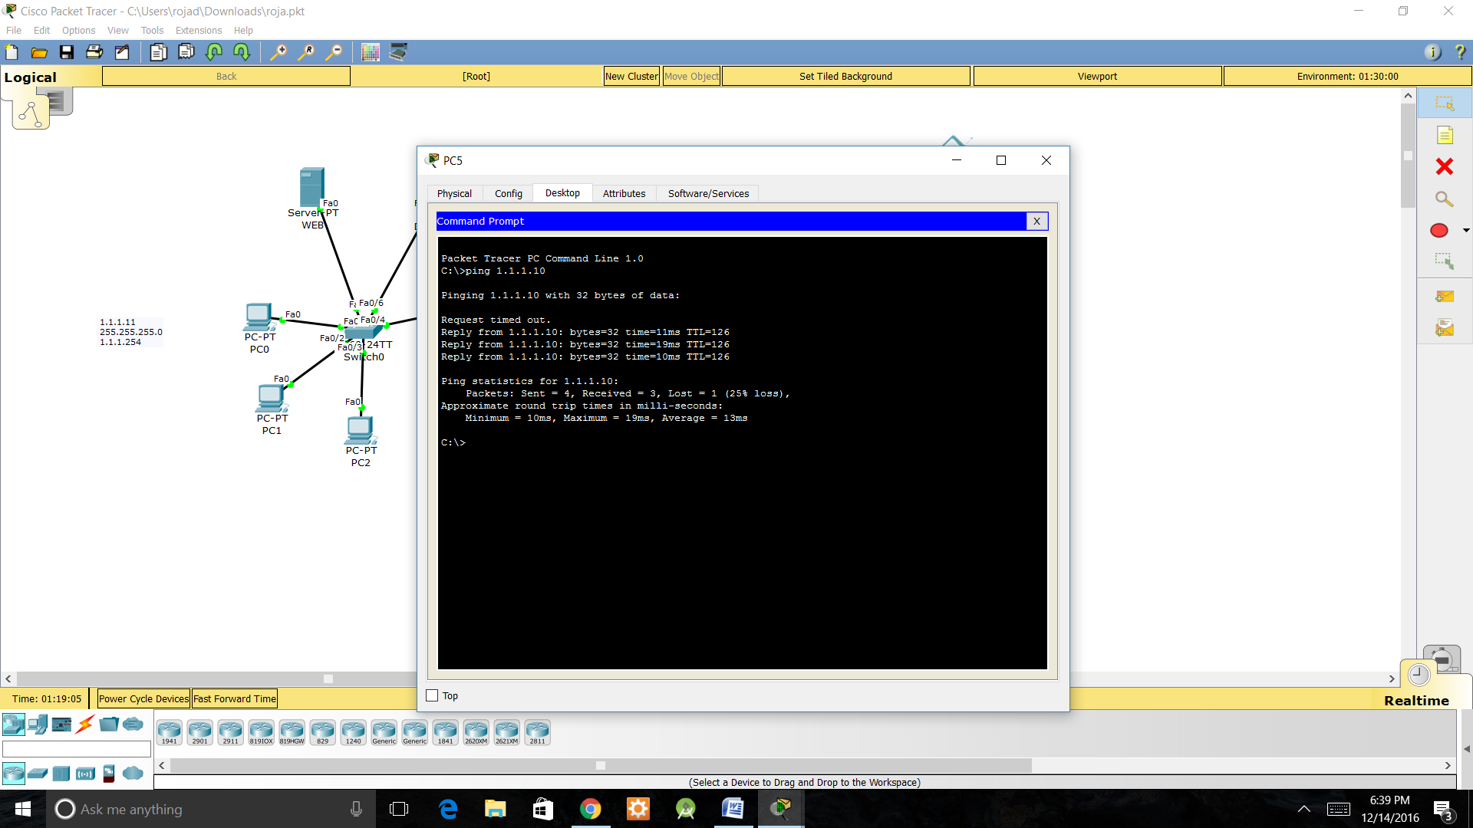

Conclusion

Our client was happy with our work. We were able to add wireless functionality to greatly increase their data access, as well as improved data filing with printed data sheets. The only real trouble was wiring the network in the specific way that the client requested, though it was a relatively simple fix and the final result functioned as intended. What we learned from this project was how to take a preexisting network and add onto it to provide extra functionality.

